Module 11: Intro to AI-powered information extraction concepts

Overview
- AI-powered info extraction/analysis enables orgs to gain actionable insights from data in documents, images, audio files, or other assets
  - Structured content – info stored in a consistent format (ex. invoices, tax forms, and tables.
  - Unstructured content – info that isn't in a predefined format (ex. emails, audio recordings, images, and videos).

Information extraction processes
- General Steps:
- 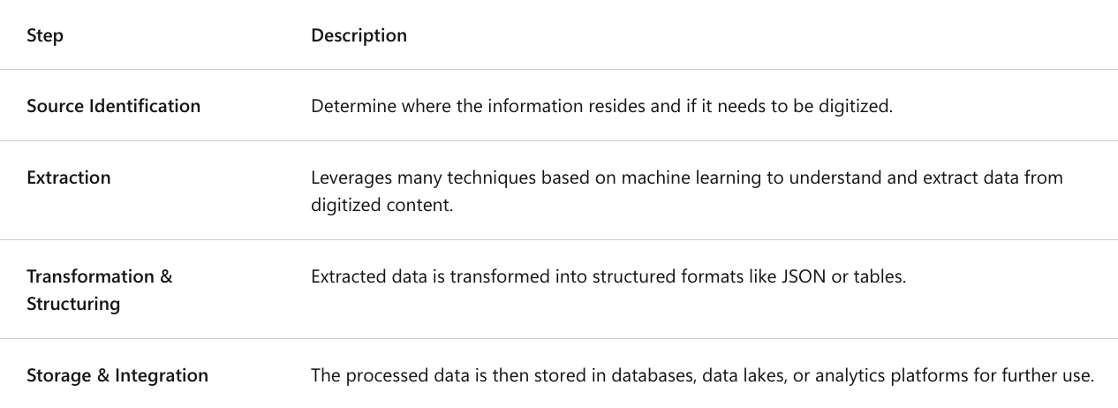

Understand the extraction of data from images
- Replaces the need to manually inspect each piece of content for insights.
- Done by using ML models to process images and transform them into numerical information.
  - Then vision models perform calculations on the numerical data to create predictions of what's in the images.
- Example: Postal Service automation to sort mail based on postal codes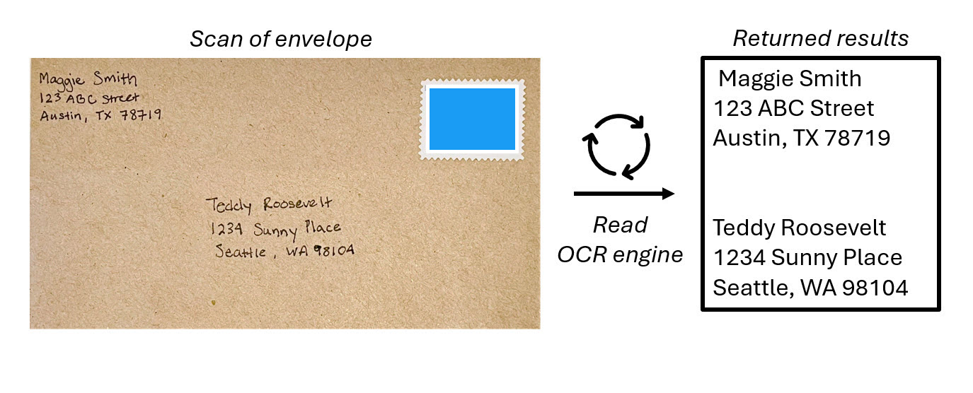
- Optical Character Recognition (OCR) helps computers recognize that an element in an image contains text and is the foundation of processing text in images

Understand the extraction of data from forms
- Forms and documents have text data with semantic meaning (intended interpretation of words, phrases, or symbols in a given context)
- Document intelligence service processes text and attach semantic meaning to the extracted text.
  - Ex. Organization can process large numbers of receipts for expenses claims, project costs, and other accounting purposes by using document intelligence.
    - Company can take a scanned image of a receipt, digitize the text with OCR, and extract semantic meaning.
  - Semantic meaning of data in forms can be described in field-value pairs.
    - The field name is the key or type of data entry.
    - The field description is the metadata of what the field name represents.
    - The value corresponds with the field name and is the data specific to the content.
  - Example: invoice, the fields recognized may include:
    - Name, address, and telephone number of the merchant
    - Date and time of the purchase
    - Name, quantity, and price of each item purchased
    - Total, subtotals, and tax values

Understand multimodal data extraction
- Using multimodal data extraction (combining multiple extraction tech.) can help with digital asset management, workflow automation, generating further insights, etc.
- Orchestration of extraction techniques can include vision and document intelligence, and others including:
  - NLP can be used to find key phrases, entities, sentiment, etc. in written or spoken language.
  - Speech recognition takes the spoken word and converts it into data that can be processed
  - Generative AI can add to the data extraction process by allowing users to identify their own fields and field descriptions.
    - Create new ‘summary’ field name
      - ‘Value’ is created based on GenAI
- Example of multimodal info extraction
  - 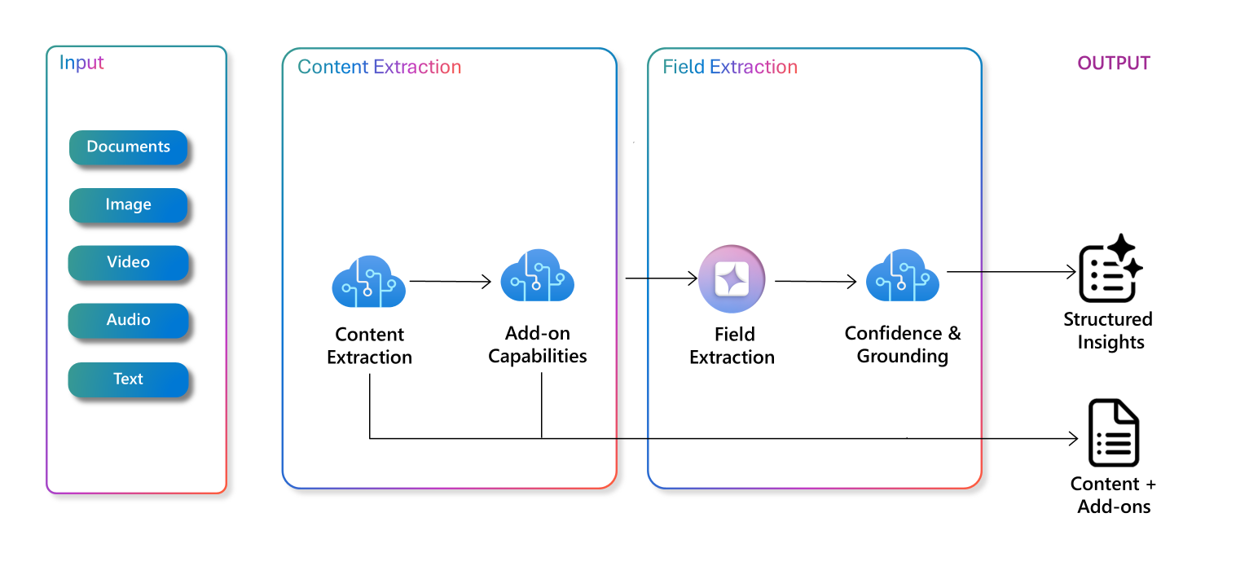

Understand data extraction for knowledge mining
- Knowledge mining solutions provide automated information extraction from large volumes of often unstructured data.
  - A foundational knowledge mining solution is search (process of getting relevant info from a large dataset in response to a user query).
- Process:
  - 1) Document cracking – opening document formats like PDFs to extract the contents as ASCII text for analysis and indexing.
  - 2) AI enrichment, which implements AI on your original content to extract more information which is then sent to a knowledge store
    - ex. Add captions to an image
  - 3) Resulting data is serialized as JSON data to populate the search index.
    - Ex. 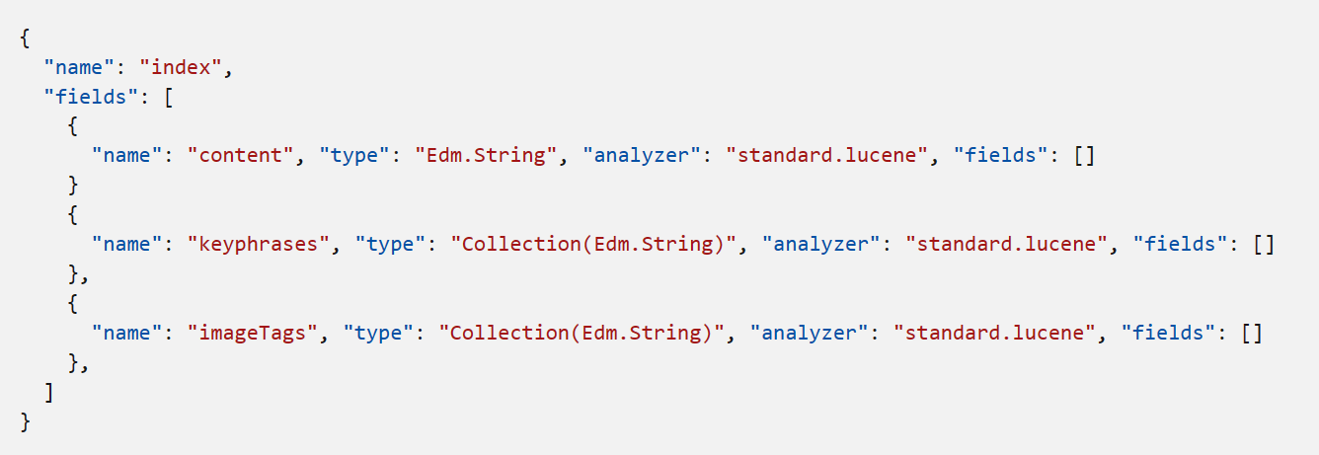
  - A result is a search solution which typically includes the following components:
    - 